RASI Driving School Management System

CSD 4010 Software Development

by

Vishnu Chakravarthi Nallaiah Raj

M00606188

**Contents**

|  |  |  |
| --- | --- | --- |
| S.no | Title | Page No. |
| I | Domain Description | 3 |
| II | Class Diagram | 4 |
| III | Invariants | 5 |
| IV | Design Decisions | 6 |

**I. Domain Description**

Background:

The RASI driving school is run by a father and his son. The administration was managed by the father and the son takes care of registration, driving class allotment and the license process. There is an office staff to manage the student records and their fee payment. The school consists of three cars and a bus and four instructors as his son being one of the instructor for the heavy classes. The bus is used for training heavy driving students. They provide three sessions, morning (06:30 - 08:30), afternoon (12:00 - 14:00) and evening (16:00 - 18:00) sessions throughout the week and a full day session (10:00 - 16:00) on weekends.

Operational Description:

The students who are enrolled with the driving school are allotted a session as per their wish. The weekday session consists of a total of three sessions. The morning and evening sessions are mostly crowded but afternoon sessions are probably empty or less crowded. So, the afternoon sessions are separated for heavy driving classes. Two cars are used for weekday classes and 10 students can participate in each session. Each student can drive 10 kilometers each day for a period of 35 days. The students those who are attending classes on the weekdays can’t attend the classes on weekends. Weekend classes are like special classes for the students who are unable to attend the classes on weekdays. One instructor is allocated for the weekly classes and two instructors are allocated for the weekend classes. A separate instructor is allocated for heavy classes. The students are allotted separate sessions as per their selection. If there are no vacancies in the opted sessions, then the staff give some suggestions of the session which has availability. If the student accepts the offer, the session is allotted for the student. The student is moved to the waiting list if the student don’t want the offered session. The students are arranged according to their date of registration in the waiting list. So, whenever there is a space in the session, the student who has registered first gets the place. Most of the students opt for weekend classes. But weekend classes are always crowded, so, the admin offers them the weekly classes. The morning and evening sessions are opted by most of the students and some students opt for afternoon classes instead of waiting.

Most of the students don’t request for a session change as they know all the sessions are crowded. But some students may need a session change despite their situation. At that time, the admin or the staff asks their preference first. If there is an availability in the preferred session, then the students are transferred to that session. The admin offers them with the available session if the preferred session is full. The students can choose one or they can ask for any specific session. If there is no availability in the preferred session, then the student is moved to the waiting list. Once there is an availability, the students are transferred to the session based on their place on the waiting list. The student should attend the whole 35 days class to get eligible for the driving test. During the classes, the students are put into many skill tests to find out their improvement day by day. This is done by the trainer during the class. He makes a note of every single test and he updates it to the administrator based on which the student can take driving tests. If the student’s performance was not so good, then he/she should take some more classes. This depends on the student’s wish to take more classes. They can attend the License test for a maximum of three times. If they fail to pass the test, then they should wait for another six months to apply for a license. So, the admin asks the student to attend extra classes if the performance is not good. The license is issued to the student only after the payment of fees without any dues. The fee management is done by the admin and there is an extra fee for additional classes.

**II. Class Diagram**

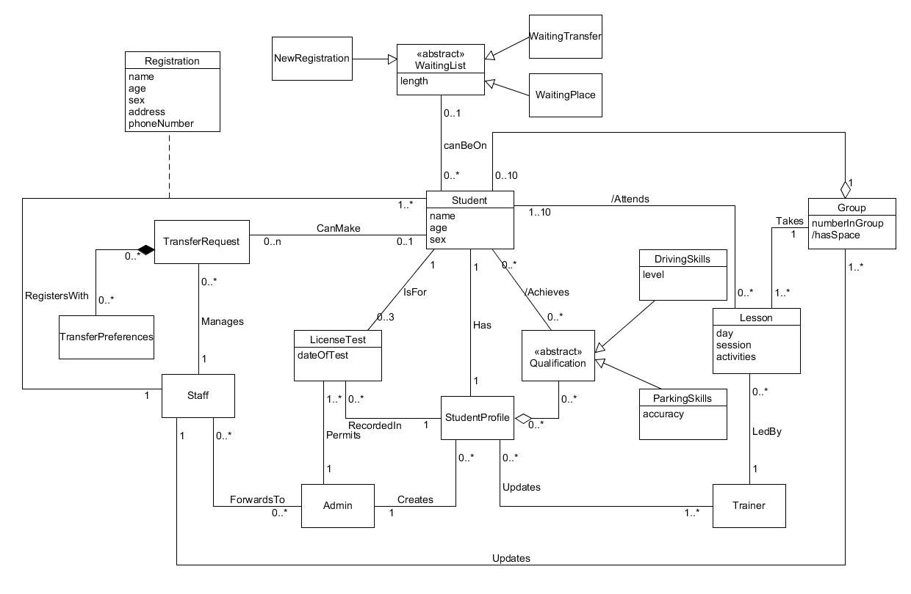

Figure 1: Use case diagram

**III. Invariants**

* For any Student object, the age attribute must be more than 17.
* If a Student object aStudent is linked to a LicenseTest object aLicenseTest and aLicenseTest object is linked to aStudentProfile object a StudentProfile, then aStudentProfile must be linked to aStudent.
* If a Student object is linked to a WaitingList object and the Student is also linked to a Group object, then the WaitingList object must be of type TransferWaitingList.
* If a Student object is linked to a WaitingList object and the Student is not linked to a Group object, then the WaitingList object must be of type NewStudentWaitingList.
* If a Student object aStudent is linked to a Group object and aGroup object is linked to a Lesson object, then aLesson must be linked to aStudent object.

**IV. Design Decisions**

|  |  |
| --- | --- |
| Design Decision | DD-1 |
| Stage | Eliminating synonyms |
| Description | Instructor is a synonym for coach, but ‘trainer’ is unique |
| Rationale | The student profile is created for the student whoever accepts the waiting list. So, the students who joins the school has a profile but not all those who are registering. |

Table 1: Design decision 1

|  |  |
| --- | --- |
| Design Decision | DD-2 |
| Stage | Keeping essential classes |
| Description | Fee management is not added to the class diagram. |
| Rationale | The payment and fee management are not included in the current class diagram which is not considered as an essential class for now. |

Table 2: Design decision 2

|  |  |
| --- | --- |
| Design Decision | DD-3 |
| Stage | Eliminating entities that are out of scope of system |
| Description | Rejecting ‘driving school’ as it describes the general purpose of the system. |
| Rationale | The driving school in the domain description describes the central idea of the system but it does not refer to entities. So, it is eliminated from the design for now. |

Table 3: Design decision 3